RESOLUTION NO.__________

RE: CERTIFICATE OF APPROPRIATENESS UNDER THE
PROVISIONS OF THE ACT OF THE PENNSYLVANIA
LEGISLATURE 1961, JUNE 13, P.L. 282 (53
SECTION 8004) AND BETHLEHEM ORDINANCE NO.
3952 AS AMENDED.

WHEREAS, it is proposed to replace the signage at 531 Main St.

NOW, THEREFORE, BE IT RESOLVED by the Council of the City of Bethlehem that a Certificate of Appropriateness is hereby granted for the proposal.

Sponsored by: (s)

(s)

ADOPTED BY COUNCIL THIS DAY OF

(s)
President of Council

ATTEST:

(s)
City Clerk

HISTORICAL & ARCHITECTURAL REVIEW BOARD

The applicant is proposing to replace the signage at 531 Main St.
APPLICATION #3:

CSF Buxmont/Judy Happ
P.O. Box 283
Pipersville, PA 18947

OWNER:

__________________________________________________________________________

The Board upon motion by Marsha Fritz and seconded by Nancy Shelly adopted the proposal that City Council issue a Certificate of Appropriateness for the following:

- The sign will be individual acrylic letters mounted to the gray panel above the aluminum and glass entrance.

- Upper portion of the blade sign to be replaced and lower panel will remain.

- Pin stripe to be added to the upper panel and all white portions to be “off-white” in color.

4. The motion was unanimously approved.
__________________________________________________________________________

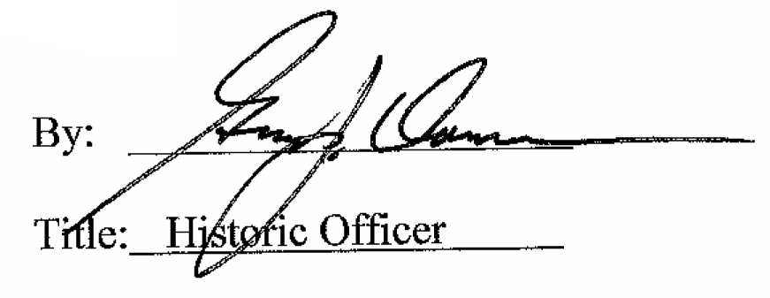

Date of Meeting: September 7, 2016

